Q1: Login Panel GUI (Design Only)
Create a Java Swing application that designs a login form similar to the given diagram.
Requirements:
Frame title: "JPanel Demo Program"
A panel with title: "Login Panel"
Add:
Username label and text field
Password label and password field
Login button
Use a suitable layout
No functionality required (No event handling)

Design:

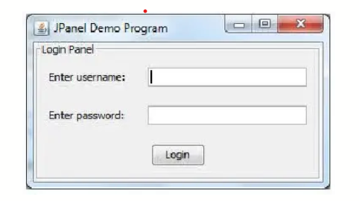

Q2: TV Remote Controller (Design Only)
Design a GUI for a TV Remote Controller.
Requirements:
Add buttons for:
Power ON/OFF
Channel Up / Down
Volume Up / Down
Media selection (TV, USB, HDMI)
Use appropriate layout and spacing
Apply colors for better UI
No functionality required (No event handling)

Q3: Login Button with ActionListener
Create a login form with username and password fields.
Task:
When user clicks the Login button:
Display message: "Login Successful"
Use ActionListener
Show output using JOptionPane

Q4: Addition with MouseListener
Create a Java Swing application that:
Takes two numbers as input
Adds them
Displays result on screen (not dialog box)
Additional Requirement:
Use MouseListener on the button (e.g., perform addition when mouse is clicked)

Q5: Number Checker with KeyListener
Create a Java Swing application that:
Takes a number as input
When user interacts:
Use KeyListener to detect input from keyboard
Task:
If number is positive → show "Positive Number"
If number is negative → show "Negative Number"
If number is zero → show "Zero"
Output:
Display result on screen using JLabel

